**Data**

The data used for this analysis was obtained from the R package, ‘nflfastr’, which compiles play-by-play date from NFL games. The entire 2020 regular season was used. 3 additional websites were also used for a few statistics, pff.com, fantasyfootballers.org, and pro-football-reference.com.

**Known Issues**

The sample size of an NFL season is extremely small for statistics.

The data source categorizes QB scrambles as rushing attempts. The scrambles were removed to look strictly at rushing attempts on called run plays when calculating run share.

**Methodology**

Utilizing the nflfastr library for R to compile play-by-play data for use in creating play, weekly, and season long comparison statistics. Football reference is also used for reference on a few advanced stats and pro football focus offensive line rankings are used for additional analysis.

**Analysis**

At first glance, these running backs look to have a clear superior. J.K. Dobbins has substantially better rush yards (805 to 521), more carries (134 to 114), better yards per carry (6.01 to 4.57) and much better yards after contact (2.9 to 1.7). However, with a little bit of a deeper dive, I believe that D’andre Swift is set up for better success into the future.

*\*\*Swift missed 3 games while Dobbins was out for 1 game.*

The first reason for this is that Swift held a larger portion of his teams run share almost through out the entire season. *(bye week and injury weeks are smoothed over for ease of reading)*

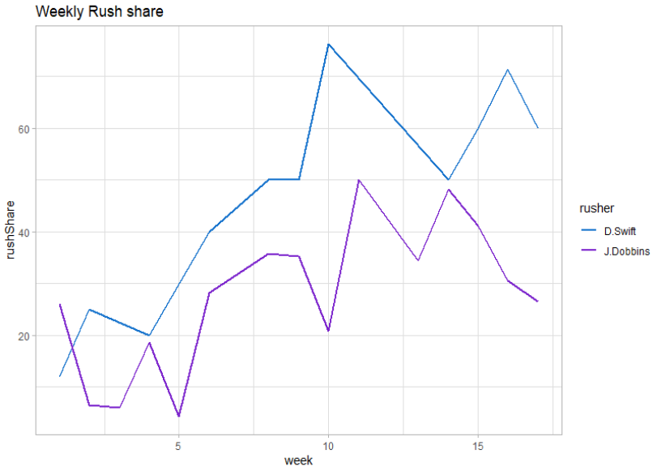

When the teams need to run, Swift’s is looking to him more often than Dobbins. Data to further back up the run share comparison is that Swift was utilized on run plays when the Lions had an average score differential of -4.98 versus Dobbins usage average at 6.41 differential. This leads me to believe that regardless of the game script, Swift is going to get his touches and as the season progressed, the Lions became more comfortable with Swift by giving him a larger workload. It is not clear if Dobbins would be scripted out if the Ravens fell behind consistently.

Second, while Dobbins has almost a league best in yards after contact (#2), Swift broke more tackles (9 to 8). He is making people miss and I would expect for this to translate into a better yards-after-contact moving forward.

Third, Swift did not have as many explosive plays (1 play over 20yds to 8) , but he was getting more total touches (rush and receiving) where it really matters in fantasy, goal-to-go ( 18 to 13). In fantasy term, TDs are king and the goal-to-goal touches are gold. This graph below shows similar distributions for the players gained yard per rush except for the difference on explosive plays.

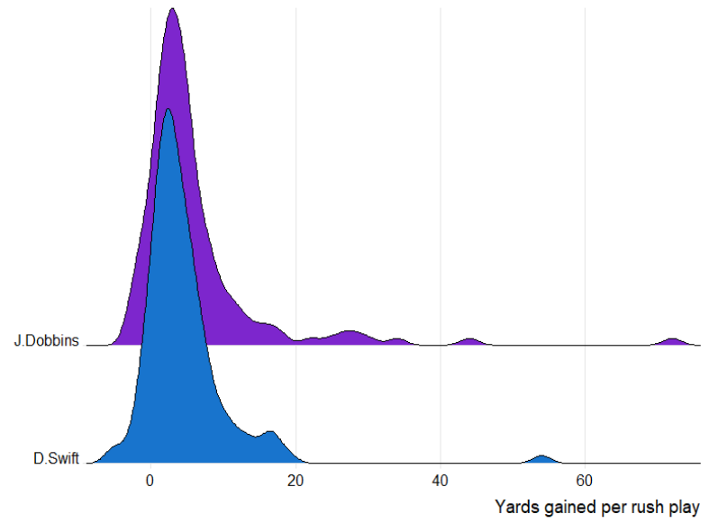

Besides the larger rush share and more redzone touches, my biggest plus for Swift is that he is much more involved in the pass game. He is a top 8 receiving running back for yd/game when filtered for 10+ receptions. (Dobbins doesn’t break that top 70)

Additional notes

Both of their offensive lines were around league average in 2020 per PFF (Lions #13, Ravens #16) but the Ravens did lose 2 key linemen (retirement and injury). The key pieces to these lines are returning to the teams so one can expect improvement from both.

Dobbins must contend with Lamar Jackson eating into his rush share which will continue along with Gus Edwards. Even though Mark Ingram is gone most of his rush share is not guaranteed to fall to Dobbins.

The Lions signed Jamaal Williams and will likely plan to use him, but I don’t believe this will impact Swift’s role as the lead back. Excluding his 3 concession weeks, Swift took over the backfield starting in week 8 (I smoothed the plot instead of flatlining to 0 in missed weeks.)

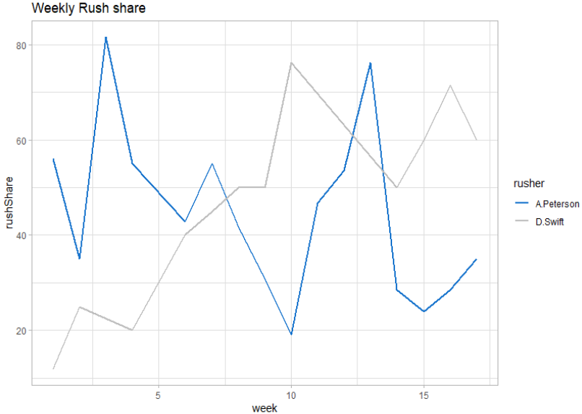

**Conclusion**

I believe that Swift is the better long term option due to a larger share of his backfield, more redzone and goal-to-go touches and a larger contribution to the teams passing game, all despite the worse boxscore stats compared to Dobbins.

*\*\* R file has code to pull pbp data, calculate run share, plot run share comps, calculate season long run share and yds + ypc, calculate and plot big plays, calculate avg. score differential on rushing touches, redzone carries, total touches and tds*

**Resources**

NFL.com - play-by-play data accessed via nflfastr

Pff.com - offensive line rankings

<https://fantasyfootballers.org/rb-running-back-nfl-stats/> - receiving yards by RB

<https://www.pro-football-reference.com/years/2020/rushing_advanced.htm> - yards after and before contact